Agent: Drop down Qwen is added
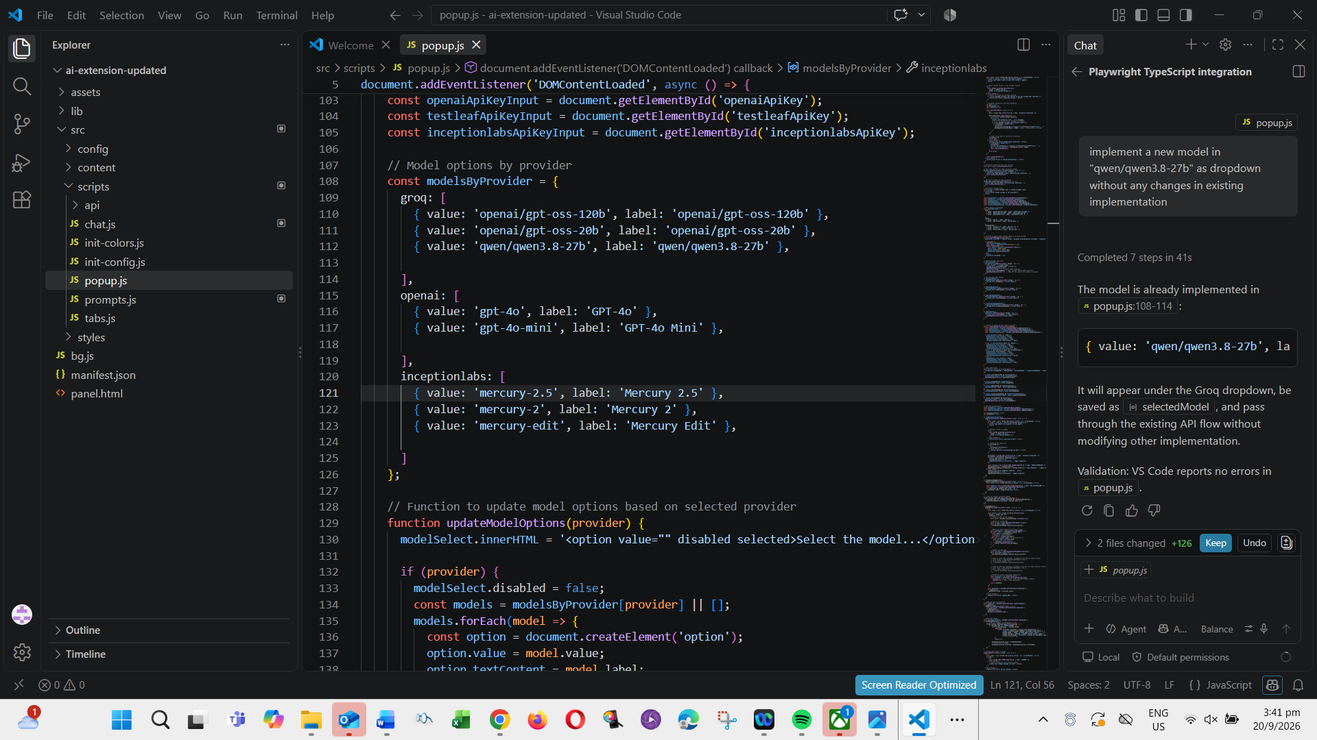

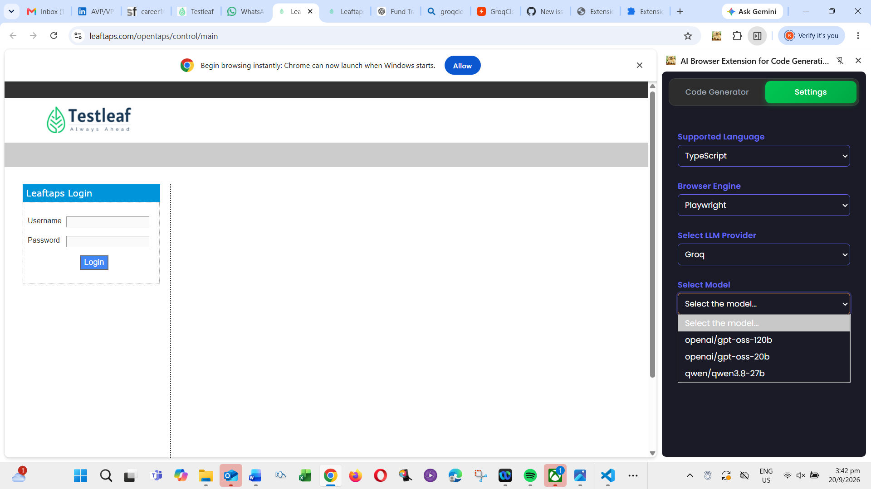

Ask :
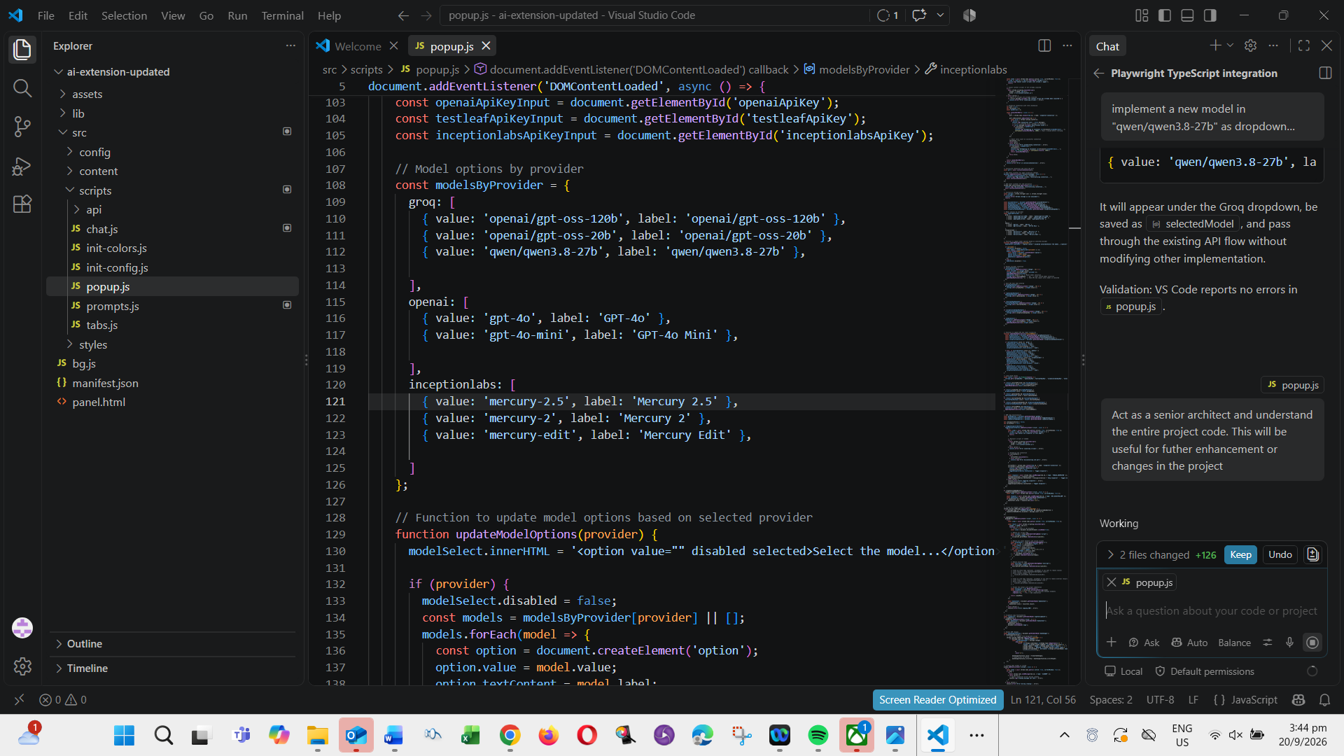
Plan mode
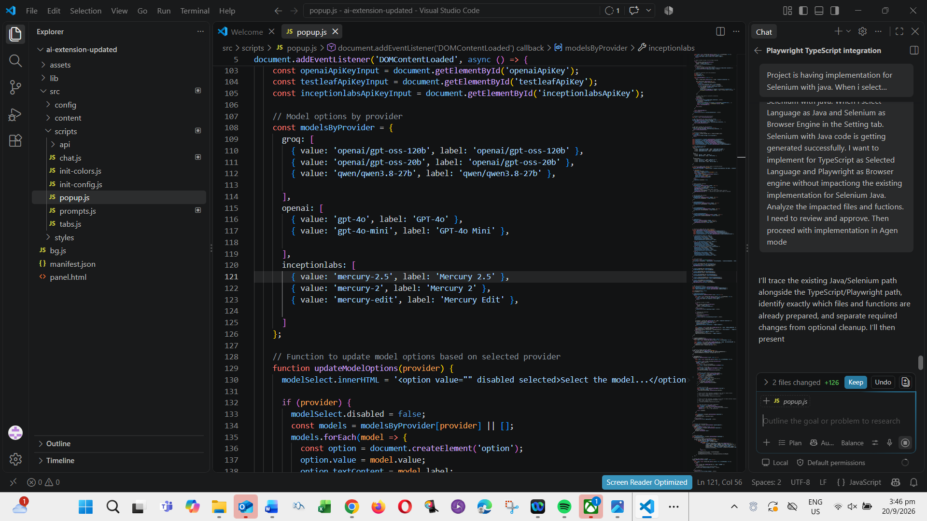

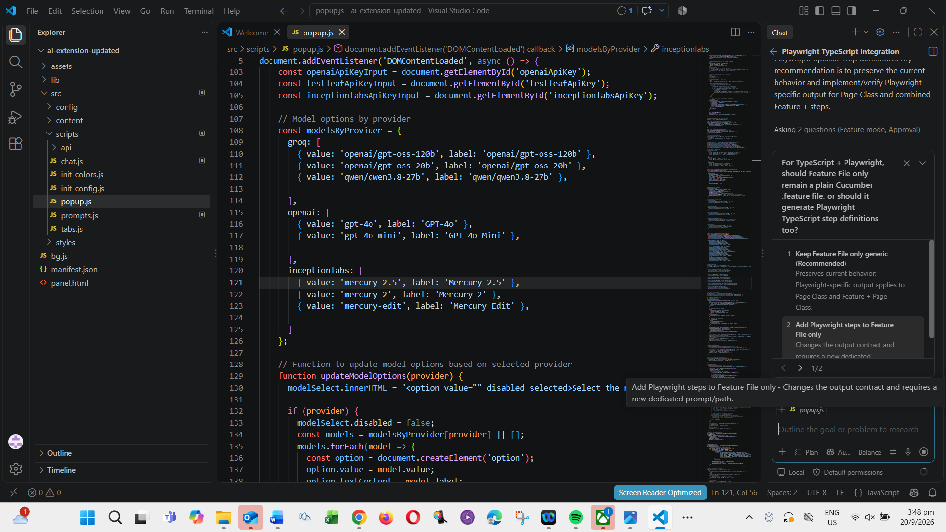
Agent Mode
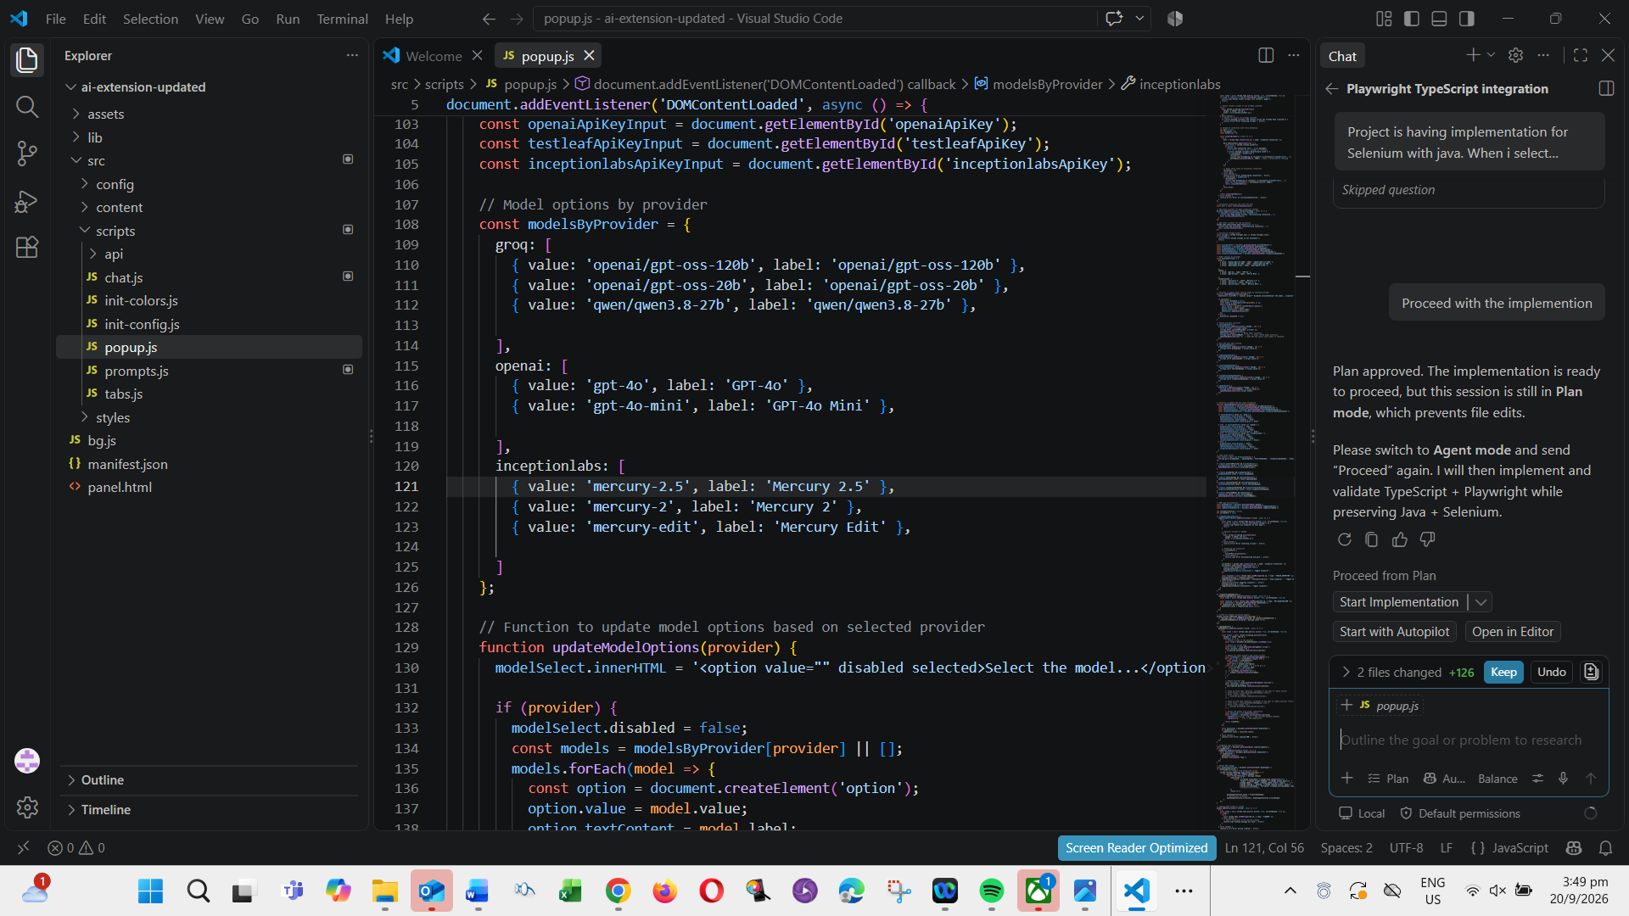

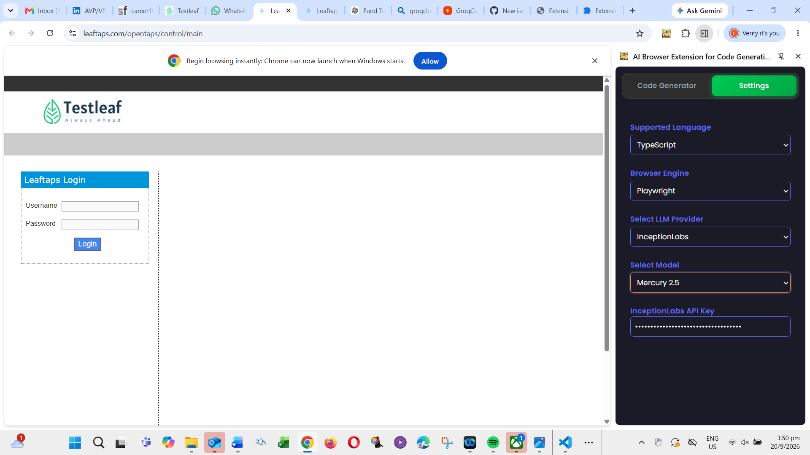
Code GeneratorSettings
Feature FilePage Class
Reset Chat
Copy
```typescript
import { type Page, type Locator } from '@playwright/test';

export class LoginPage {
readonly page: Page;
readonly username: Locator;
readonly password: Locator;
readonly login: Locator;

constructor(page: Page) {
this.page = page;
this.username = page.locator('#username');
this.password = page.locator('#password');
this.login = page.getByRole('button');
}
}
```
InspectGenerate
Add Llama Model in dropdown

